Prototype Analysis

Through the results of the Survey, Questionnaires & Observation elicitations I have formulated several prototypes to help visually show the breakdown of the flaws in the NCI website and what we propose to do to overcome them. The prototypes were developed using tools such as white boards, Word and a wireframe software called Pencil.

From the Survey & Questionnaires it was clear that majority of the individuals that access NCI website did so through a PC and largely were disappointed with the use of Moodle and the difficulty with access information. Secondly through our Observation of user’s navigating the web page it was clear certain features were hard to find as the information was scattered randomly across the webpage so was mentioned by the users it was difficult to complete a task within one location without having to leave to seek other details. The user also found they had to make several clicks before they reach their destination. Overall the NCI webpage appears to be unorganised and frustratingly difficult to use from a general user’s perspective.

**Prototype V0.1**

Prototype version 0.1 is our first attempt to address the redesign of the website, through this method as seen below we attempted to develop a consensus of the Hierarchy so that we could make the lay out more efficient meaning reduced clicks. We mainly based this around the available courses and the information relevant to them as it was the main point of interest for users in the Observation tests. Here we also attempted to develop what information we should include at the various stages through the webpage.



**Prototype V0.2**

At this stage, we were interested in coming up with a web page template and so we played around with some designs on a white board which you can see an example of below. This allowed us to gage the proportion of the web page in the sense of what material needs to be listed and what can leave out so that the webpage does not appear bloated. We also gained the chance to ask ourselves what fashion can we display the topics etc. through drop down bars, scowling and various containers on the page. Overall, we found the NCI web page looked well but mainly needed reduced information which allowed us to consider salvaging some of the design layout such as the home page.

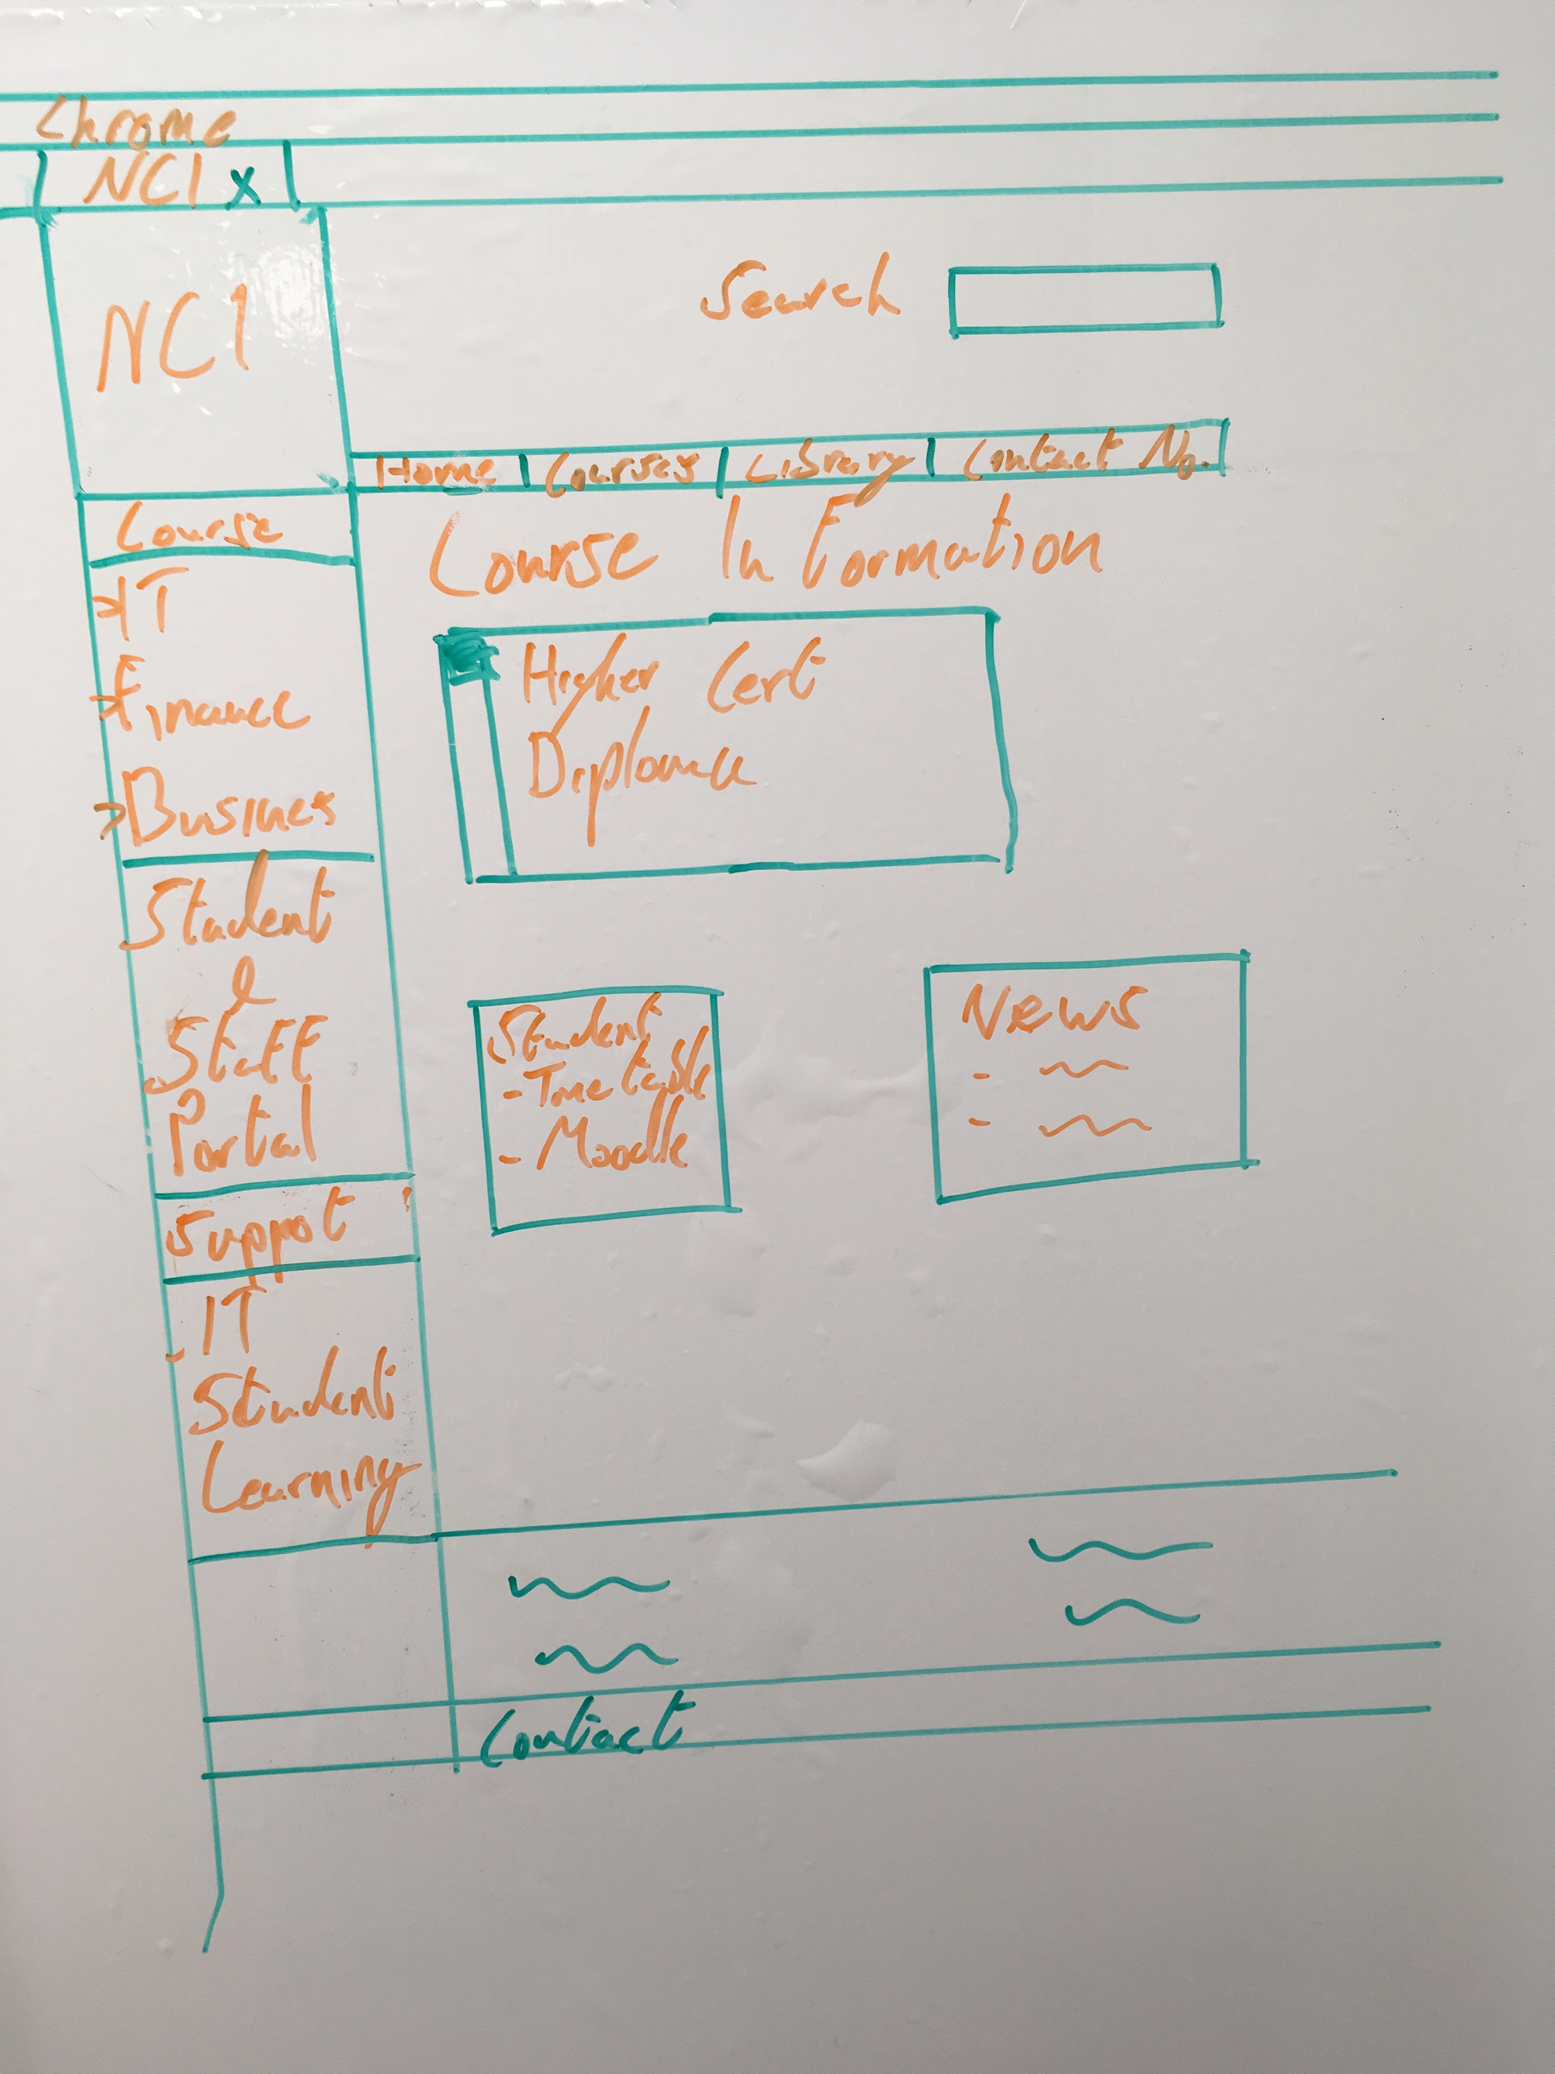

**Prototype V0.3**

This prototype is the final piece which is a combination of prototype V01 & V02 but with added elements. The Pencil application was particle helpful as it allowed us to implement and trial various additional elements because it was visual dynamic to manipulate.At this stage, we had a greater understanding on what we aimed to do in a wireframe prototype which allowed us to achieve greater detail and clarify on what our developed web page would look like. As you can see below I have attached a PDF with several wire frame examples which shows our hierarchy idea in play and with what we learned from the users through the questionnaires and observations. We attempted to map out the various stages a user would go through when querying what courses are available and what they may need to know. In the example below you will see that much of the information they may seek can be obtained with 3 clicks or more.

















